Racing SubSystem

ERD for UX process

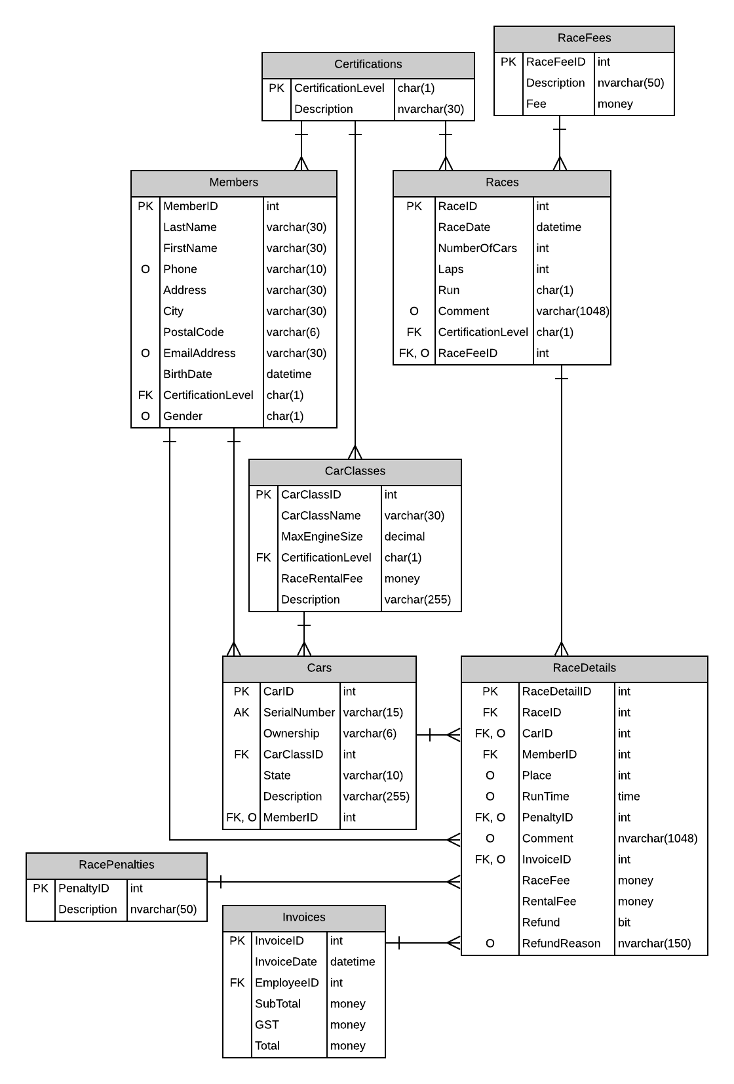

Possible UX Interface

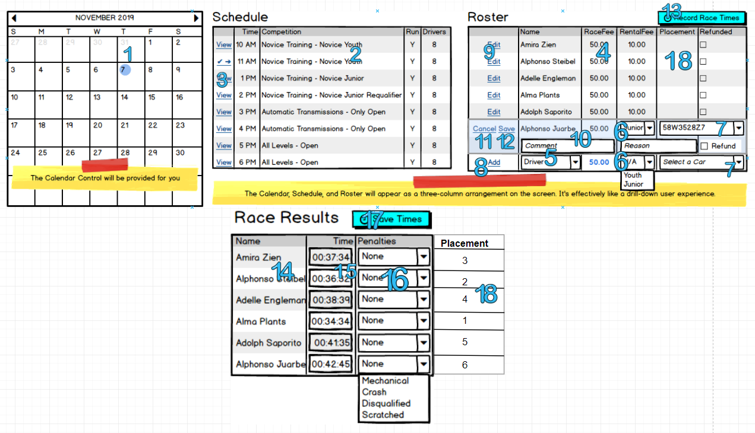

Event and Wiring Summations

|  |  |  |
| --- | --- | --- |
| **Controls** | | **Events** |
| SelectedDate(1), Races(2) | | Onclick / wired via ObjectDataSource   * Move selected value to RacesBy which identifies selected date(hidden field) * Call BLL * Bind data to Races |
| **BBL Class(es) and Method (s)** | | |
| RacesController | List<RaceList> List_RacesForDateSelection(datetime runtime, string competition, bool run, int numberofcars)  Retrieve a list races for supplied selection type. Return runtime, certification, carclass, run and numberofcars for the selected date. Display in Races | |
| **SQL Table(s): (C,R,U,D)** | | **Entities/DTOs/POCOs** |
| Races (R), RaceDetails(R), Certifications(R), CarClasses(R) | | RaceList (P) |

|  |  |  |
| --- | --- | --- |
| **Controls** | | **Events** |
| ViewRace(3), Drivers(4), DriversDDL(5), CarClassesDDL(6) | | OnClick / wired via ObjectDataSource   * Move selected value to DriversBy, which identifies selected race(hidden field) * Call BLL * Bind data to Drivers, DriversDDL, CarClassesDDL |
| **BBL Class(es) and Method (s)** | | |
| DriversController | List<DriverList> List_DriversForRaceSelected(string fullname, money racefee, money rentalfee, string carclass)  Retrieve a list of drivers for supplied selection type. Return fullname, racefee, and rentalfee, carclass for the selected race. Display in Drivers, DriversDDL, CarClassesDDL | |
| **SQL Table(s): (C,R,U,D)** | | **Entities/DTOs/POCOs** |
| Members (R), RaceFees (R), CarClasses (R) | | DriverList (P) |

|  |  |  |
| --- | --- | --- |
| **Controls** | | **Events** |
| CarsDDL (7) | | OnSelected/ wired via ObjectDataSource   * Move selected value to CarsBy, which identifies selected carclass * call BLL; * Bind returned data to carsDDL |
| **BBL Class(es) and Method (s)** | | |
| CarsController | List< CarList > List_CarsForCarClassSelected(string carclass)  Retrieve a list of cars for supplied car class description. Return serialnumber. Display in CarsDDL. | |
| **SQL Table(s): (C,R,U,D)** | | **Entities/DTOs/POCOs** |
| CarClasses (R), Cars(R) | | CarList (P) |

|  |  |  |
| --- | --- | --- |
| **Controls** | | **Events** |
| Add (8), Drivers (4), DriversDDL (5) | | Add OnClick/ wired via ObjectDataSource   * Move selected value to DriverDetailsBy, which identifies selected DriverDDL(hidden field) * call BLL; * Add a new driver to Drivers * Bind returned data to Drivers * Refresh Drivers |
| **BBL Class(es) and Method (s)** | | |
| DriversController | void Driver_Add(string fullname , int membered, money racefee)   * Verify selected driver is not in that race already * Add new driver to Drivers | |
| **SQL Table(s): (C,R,U,D)** | | **Entities/DTOs/POCOs** |
| Members (R), RaceFees (R), RaceDetails(C) | |  |

|  |  |  |
| --- | --- | --- |
| **Controls** | | **Events** |
| Edit (9), DriverDetails (10), CarClassesDDL (6) | | Edit OnClick/ wired via ObjectDataSource   * Move selectied value to DriverDetailsBy, which identifies selected driver(hidden field) * call BLL; * Bind returned data to DriverDetails |
| **BBL Class(es) and Method (s)** | | |
| DriversController | Driver Driver_Get(int memberid)  Retrieve a single record of drivers for supplied driver id. Return fullname, rentalfee, carclass for the selected driver. Display in DriverDetails, CarClassesDDL. | |
| **SQL Table(s): (C,R,U,D)** | | **Entities/DTOs/POCOs** |
| Members (R), RaceFees (R), CarClasses (R) | | DriverDetails (P) |

|  |  |  |
| --- | --- | --- |
| **Controls** | | **Events** |
| Cancel (11), Drivers (4), DriversDDL (5), CarClassesDDL (6) | | Cancel OnClick/ wired via ObjectDataSource   * Call BLL * Return to the previous page * Bind data to Drivers, DriversDDL, CarClassesDDL |
| **BBL Class(es) and Method (s)** | | |
| DriversController | List<DriverList> List_DriversForRaceSelected(string fullname, money racefee, money rentalfee, string carclass)  Retrieve a list of drivers for supplied selection type. Return fullname, racefee, and rentalfee, carclass for the selected race. Display in Drivers, DriversDDL, CarClassesDDL | |
| **SQL Table(s): (C,R,U,D)** | | **Entities/DTOs/POCOs** |
| Members (R), RaceFees (R), CarClasses (R) | |  |

|  |  |  |
| --- | --- | --- |
| **Controls** | | **Events** |
| Save (12), Drivers (4), DriversDDL (5), CarClassesDDL (6) | | Save OnCLick   * Collect full name, racefee, car class, serial number, comment, reason, refund and validate (reason data is entered); * send to BLL for updating Drivers; * refresh Drivers. |
| **BBL Class(es) and Method (s)** | | |
| DriversController | void Update_DetailsInDriver(string customername, money racefee, string carclass, int serialnumber, string comment, string reason, bool refund)  DriverDetails   * find driver * update carclass, serialnumber, comment, reason, refund * validate entered data is valid   update new driver details | |
| **SQL Table(s): (C,R,U,D)** | | **Entities/DTOs/POCOs** |
| RacesDriverDetails(U) | |  |

|  |  |  |
| --- | --- | --- |
| **Controls** | | **Events** |
| RecordTimes(13), RaceResults (14), PenaltiesDDL(16) | | OnClick / wired via ObjectDataSource   * Move selected value to DriversBy, which identifies selected race(hidden field) * Call BLL * Bind data to RaceResults, PenaltiesDDL |
| **BBL Class(es) and Method (s)** | | |
| RaceResultsController | List<ResultsList> List_ResultsForRaceSelected(string fullname)  Retrieve a list of results for supplied selection type. Return fullname for the selected race. Display in Drivers | |
| **SQL Table(s): (C,R,U,D)** | | **Entities/DTOs/POCOs** |
| Members (R), Penalties (R) | | RaceResultList (P) |

|  |  |  |
| --- | --- | --- |
| **Controls** | | **Events** |
| SaveTimes (17), RaceResults (14), Times (15), PenaltiesDDL (16), Placement (18), Drivers (4) | | Save OnCLick/ wired via ObjectDataSource   * Collect full name, time, penalty and validate (time data is entered and penalty is selected); * send to BLL for updating RaceResults; * refresh RaceResults and Drivers |
| **BBL Class(es) and Method (s)** | | |
| RaceResultsController | void Update_DetailsInRaceResults(string fullname, time runtime, string penalty, int placement)  RaceResults   * generate placement by the runtime(lowest runtime gets the lowest placement starting at 1) * update runtime, penalty, placement * validate entered runtime is valid(positive)   update new RaceResultDetails and Drivers to reflect changes | |
| **SQL Table(s): (C,R,U,D)** | | **Entities/DTOs/POCOs** |
| RacesDriverDetails(U), Drivers(U) | |  |